UNITED REPUBLIC OF TANZANIA

PRESIDENT’S OFFICE
REGIONAL ADMINISTRATION AND LOCAL GOVERNMENT

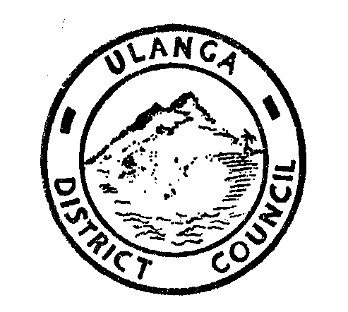

ULANGA DISTRICT INVESTMENT PROFILE

DISTRICT EXECUTIVE DIRECTOR,
P.O.BOX. 22,
MAHENGE/ULANGA.
PHONE: 255-023-2620340.
Fax: 255-023-2620346.
E-MAIL: ded@ulangadc.go.tz or mipango@ulangadc.go.tz

TABLE OF CONTENTS
1 ULANGA DISTRICT MAP iii
2 1.0 INTRODUCTION 1
1.1 1.1 Location and boundaries 1
1.2 1.2 Land Area 1
1.3 1.3 Population 1
1.4 1.4 Administrative Location in the Council 1
1.5 Administration committee and Department in the Council 1
1.6 1.6 Physical features 3
1.7 1.7 Climate and Agro ecological zones: 3
3 2.0 DISTRICT VISION, MISSION AND OBJECTIVE. 3
1.1 2.1 Vision: 3
1.2 2.2 Mission: 3
1.3 2.3 Functions of the Council 4
1.4 2.4 General Objectives of the Council 4
4 3.0 POTENTIAL INVESTMENT OPPORTUNITIES IN ULANGA DISTRICT 5
1.1 3.1 Investment Opportunities in Mining and Quarrying Sector 5
1.2 6.2 Investment Opportunities in Agriculture Sector 7
1.3 3.3 Investment Opportunities in Irrigation Sector 9
1.4 3.4 Investment Opportunities in Beekeeping Sector 11
4.4.1 Village Land Forest Reserves 11
4.4.2 National Forest Reserves 12
1.5 3.5 Investment Opportunities in Social Sector (Education) 14
1.6 3.6 Opportunities in Fisheries Sector. 15
1.7 3.7 Investment Opportunities in Tourism Sector 16
4.7.1 Caves 16
4.7.2 Sali Waterfalls 17
3.8 Opportunities in wildlife sector. 19
6.9 Investment Opportunities in Commercial Building 19
5 4.0 CONCLUSION 20

TABLE NO 1. ULANGA DISTRICT MAP

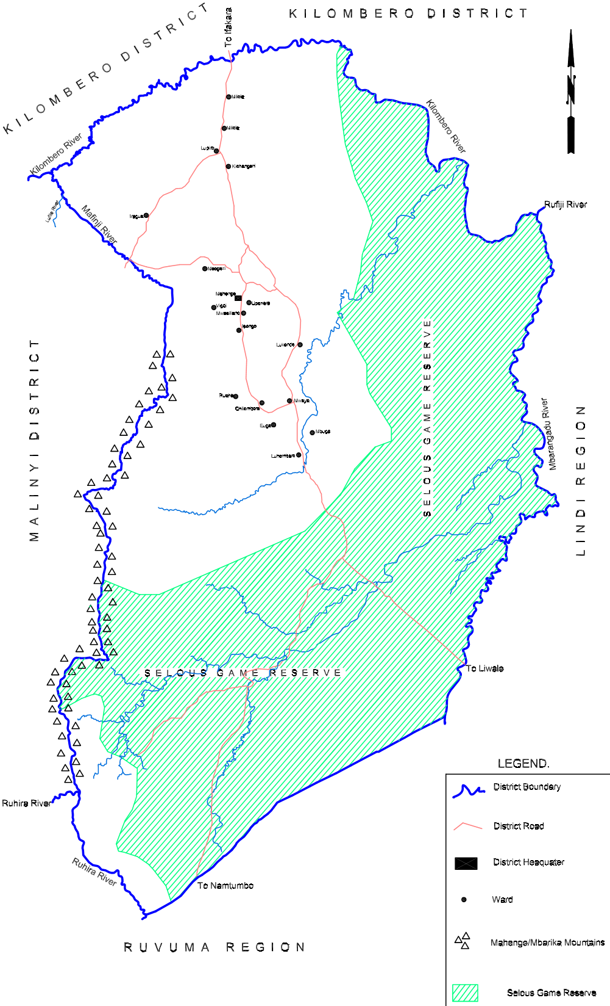

1.0 INTRODUCTION

1.1 Location and boundaries
The District is located to the Southwest of Morogoro Region. The District headquarters is Mahenge located 312km from Morogoro Municipality, 512 km from Dar es Salaam City. It borders with Kilombero District to the West and extends to the North, Liwale District to the East and Malinyi District to the South and West.

1.2 Land Area
The District has a total area of 10,688.89Sq kilometres. Most of the total area is protected forests and wildlife sanctuaries. These include the famous Selous Game Reserve to the South and East and Kilombero (South) Game controlled area to the North and East.
Table No. 1 Land distribution and usage.
No | Type of Usage | Current Number of Ha | Suggested Number of Ha | Percentage
1 | Mahenge Town | 3,109.65 | 3,109.65 | 0.29
2 | District Forest | - | 57,284.9 | 5.36
3 | Selous Game Reserve | 505,711.55 | 505,711.55 | 47.3
4 | Kilombero Forest Reserve | 31,863.32 | 31,863.32 | 2.98
5 | Planning Area | 5,538.04 | 5,538.04 | 0.52
6 | Open Forest | 81,452.54 | 24,167.64 | 2.26
7 | Scatterd Farms | 28,331.29 | 28,331.27 | 2.65
8 | Irigation Farming | - | 8,172.35 | 0.76
9 | WMA | 114,931 | 113,020.9 | 10.6
10 | Agriculture Farming | 241,444.05 | 227,302.06 | 21.3
1 1 | Commercial Agriculture Farming | 44,169.92 | 44,169.92 | 4.13
12 | Forest Reserves | 12,337.27 | 12,337.27 | 1.15
14 | Investment Land | - | 413.6
Grand total |  | 1,068,889.43 | 1,068,889.43 | 100

1.3 Population
According to the 2012 population and housing census, the district had a population of 151,001 people (males 75,348 and female 75,653). The District population growth rate is 2.9% per annum. The population of the district by the year 2016 is estimated to be 169,294. Average house hold is 4.5.

1.4 Administrative Location in the Council

The district has one constituency namely Ulanga. Administratively, Ulanga District is divided into four Divisions namely; Vigoi, Mwaya, Ruaha and Lupiro. The district has 21 Wards, 59 registered villages and 222 hamlets.

1.5 Administration committee and Department in the Council

Ulanga District Council has four standing committee namely Administration, Finance and Planning, Social services Committee, Economic and Environment committee and Council Multisectoral HIV/AIDS committee. Also the council has 13 department and 6 sections which operate in the council.

1.6 Physical features

Large part of the forest is wilderness comprising of primary submontane forests with some rocky outcrops and rocky vegetation, submontane dry grasslands and submontane wetland area.

Grasslands occur on the edges of the most reserves with wetland areas throughout the forests. Vegetation cover is river line lowland and semi- evergreen drier lowland. Altitude range from 500-900 m asl. The Kilombero river valley is the largest wetland in the district currently designated wetland reserve. It serves two districts Kilombero and Ulanga

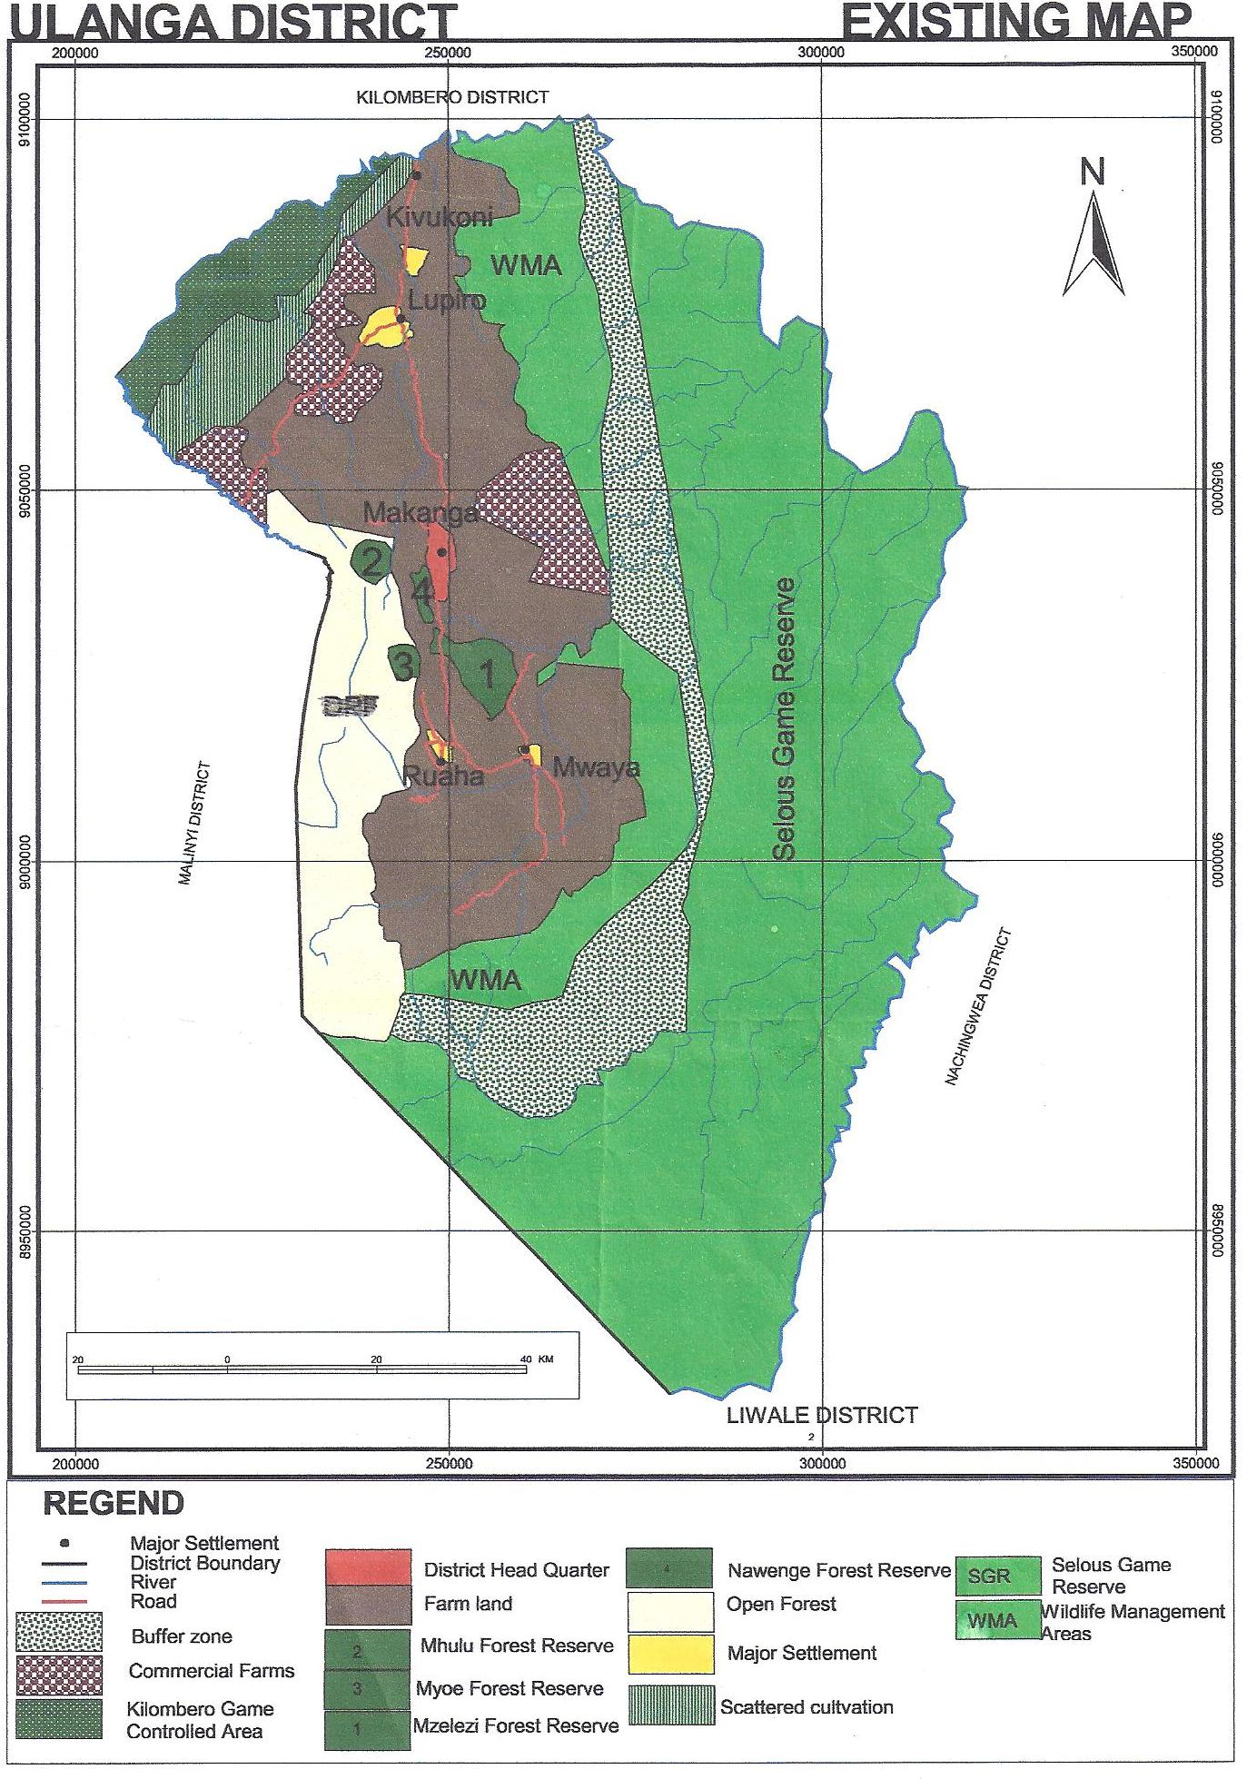

1.7 Climate and Agro ecological zones:

The District experiences a bi-modal rainfall pattern with long rains between March and May and short rains between November and January. The average annual rainfall varies between 800 mm and 1600mm every year. The daytime temperature ranges from 18⁰C min (July) to 26⁰C max (November). The district has three Agro-Ecological zones which are highlands (1300-1500 m asl), mid-altitude (1200 m asl) and lowlands (up to 500m asl).

2.0 DISTRICT VISION, MISSION AND OBJECTIVE.

2.1 Vision:
Ulanga District Councils aspires to deliver high quality services to its community for sustainable development by the year 2025.

2.2 Mission:
Ulanga District Council intends to provide high quality services to its community through effective and efficient utilization of the available resources by adhering principles of good governance for sustainable development.

2.3 Functions of the Council
According to the Local Government (District Authority) Act No.7 of 1982 (CAP 287 R.E) the council has the following general functions
- To maintain and facilitate the maintenance of peace, order and good governance with it area of jurisdiction
- To promote the social welfare and economic well-being of all persons within it area of jurisdiction and
- Subject to the national policy and plans for rural and urban development, to further the social and economic development of its area of jurisdiction

2.4 General Objectives of the Council
- To improve services and reduce HIV/AIDS infections.
- Enhanced, sustained and effective implementation of the National Anti-Corruption strategy.
- Improve access, quality and adequate social services delivery
- Increased quantity and quality of social services and infrastructure
- Enhanced good governance and administrative services
- Improved social welfare, gender and community empowerment
- Improved emergence preparedness and disaster management.
- The Quality, sustainable utilization and legal protection of natural resources in the District improved

3.0 POTENTIAL INVESTMENT OPPORTUNITIES IN ULANGA DISTRICT

3.1 Investment Opportunities in Mining and Quarrying Sector
Ulanga District has potential investment opportunities for mining exploration, gemstones mine project, both commercial and small scales mining, the common mines are, graphite, spinel, rubies, gold oil and gas in the floodplain.
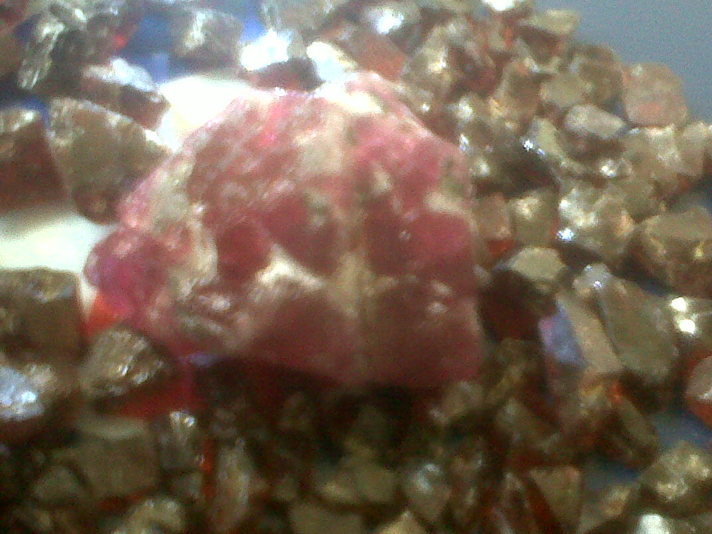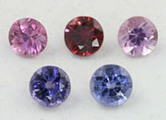
Gold Ruby Spinal
There are many mining sites in the district, but most of the mining operations are in small scale.
The kinds of gemstone currently mined in the district are Spinal, gold and ruby. There are sites also used for mining sands for construction purposes in different areas in each Division. Spinal and ruby are mined at Epanko while Gold is mined in different areas such as Mgolo, Sali and Ligamba forest reserve.
Proposed investment | Modern machinery and facilities for mine exploration
Potential Target Areas/Locations | Epanko, Mgolo, Sali, Kituti and Lukande
Type of Investors | Mine exploration, mine trade, mine consultancy, modern quarry equipment, building materials
Infrastructure | - Available road network 322km from Morogoro  - Electricity is available within 1km  - Water supply is available direct to site
Communication | - Mobile network available, Airtel, vodacom and Tigo  - Reliable Internet services available
Land acquisition | - Subject to Compensation contract Farming, partnership
Land Surveying | - Not surveyed, already identified and preparation of Town planning Drawing is on going.
Casual labourers | - Subject to open negotiation,

Mining Activities in Epanko Village
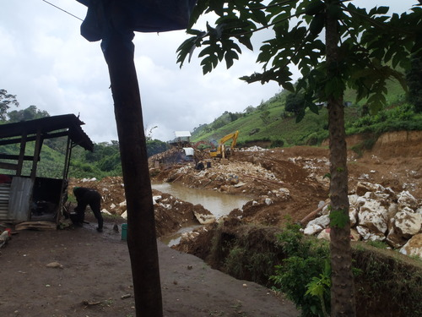

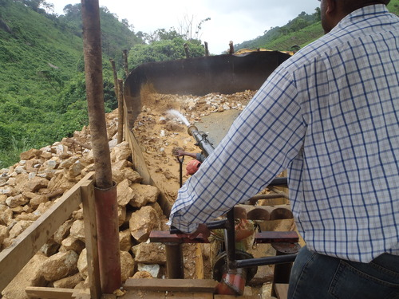
Local mining equipment.
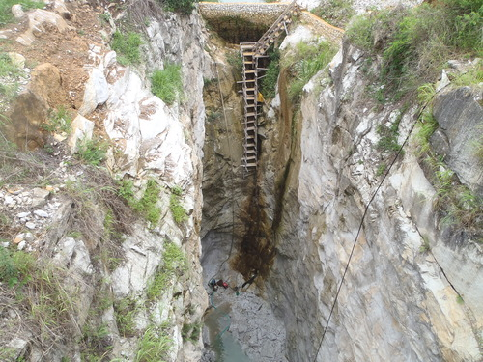
Poor mining technology.

3.2 Investment Opportunities in Agriculture Sector
Agriculture is the major economic activity in Ulanga District. The industry serves 90 % of the District population in income generation for running the day to day activities. However, the majority of the population (about 90%) depends mainly on traditional rain fed subsistence agriculture. The Council in collaboration with development partners is working hard to support farmers to increase productivity and food security so as to improve their standard of living.

The District is divided in to three agro-ecological zones namely; lowland agro-ecological zone, mid agro-ecological zone and highland agro-ecological zone. Land degradation is a common practice in most areas of mid and highland agro-ecological zones.
There is drastic declining of food production (Paddy and Maize being the major crops) with time due to climate change. Also the prevailing production systems i.e. continuous shifting cultivation characterized by severe deforestation and wild fires which in turn contributes to severe soil erosions. Hence, it is in the intension of Council extension system and the farmers to develop participatory land use management and disseminate suitable soil conservation practices for increased food production and sustainable income.

The district has 11,124 Hectors potential for irrigation agriculture, however only 1,372 hectares are irrigated (improved and traditional irrigation schemes). This implies that much effort needs to be done to rehabilitate and improve existing irrigation schemes and development of new schemes which will enhance crop productivity and profitability to ensure poverty alleviation to the community. Currently, the District is constructing 3 large schemes namely; Euga, Lupiro and Minepa which will bring more area (about 3,668 hectares) under irrigation.

The Council has now started to support its people to grow perennial cash crops in order to increase and sustain their income. The District has supported farmers to improve Cashew nut production in low land agro ecological zones (Mwaya, Lupiro and Ruaha Divisions). The District has purchased 1102 kg of Cashew nut seeds and 55,267 seedlings and distributed to farmers which in turn has enabled them to establish 477 hectares. Also, the District has supported farmers to rejuvenate 5,400 old Cashew nut trees by providing them with 10 motorized blowers and 965 litres of pesticides (Fungicides and insecticides).

Ulanga district is focused too well come investor in the seed production in ulanga district, were committed to secure land jointly and develop partnership with our famers filed, were are also committed to work with an investor for fertilizer production more preferable organic fertilizer and biological insect side killers.

Proposed investment | - Storage facilities  - Agricultural processing and packing industries, seed production around main rivers such as Luli,Ruaha,and Kilombero, agriculture implement such as fertilizer , farmers training centre
Potential target Areas  and Locations | Lupiro, Mwaya,and Ruaha
Market Situation | Markets Available for agricultural products (Paddy) within the district and outside such as Ruvuma, Iringa, Morogoro, Pwani and Dar es Salaam. Export Potentials to neighboring Countries of Mozambique and Malawi.
Transportation/Roads | Truck Transportation from Ulanga (inclusive all Divions) to all major urban centres in Morogoro, Dar Es Salaam and Pwani.
Electricty. | Lupiro and Mwaya (National Grid)

3.3 Investment Opportunities in Irrigation Sector
Ulanga district is endowed with potential areas for irrigation. The district has areas suitable for large, medium and small scale irrigation schemes such as Euga, Minepa, and Lupiro.
Potential areas for Irrigation
SN | Village/Area | Potential area for Irrigation (Ha)
1 | Lupiro | 4,000
2 | Minepa | 1800
3 | Euga | 440

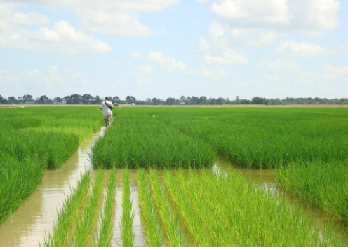
Minepa Irrigation Scheme

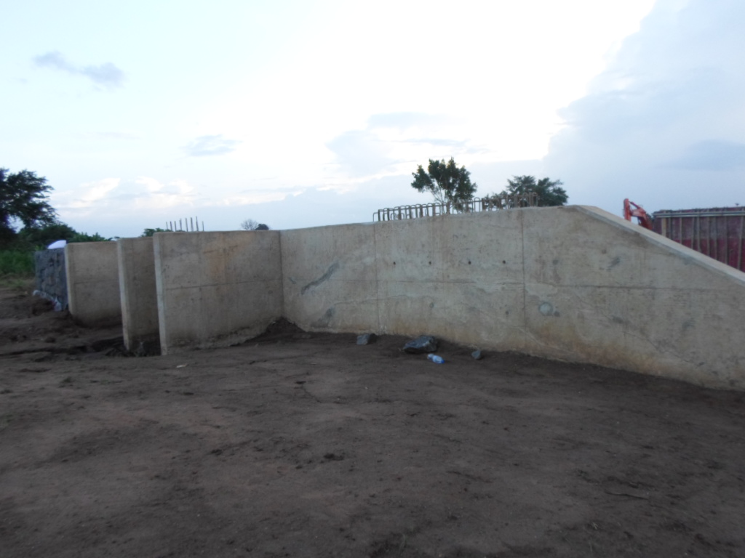
Euga irrigation scheme under construction

Proposed investment | Local, Foreign or Joint Venture who is ready to partner with  the village government on contract farming.
Potential target Areas  and Locations | Lupiro, Luhombero, Ruaha, Lukande, Mbuga
Transportation/Roads | Truck Transportation from Ulanga (inclusive all Divions) to all major urban centres in Morogoro, Dar Es Salaam and Pwani.
Electricty | Lupiro, , and Usangule. (National Grid). Except Luhombero, Lukande and Mbuga
Water | Rivers ( Luri at Lupiro, Usangule at Madibira and Usangule, Sofi and Majiji Sofi river, Furuariver at Malinyi and Tanga, Kivukoni kilombero river, Luhombero river for Luhombero and Mbuga,Lukande river for Lukande area, Mnyera for Igawa and Ihowanja area

3.4 Investment Opportunities in Beekeeping Sector
Ulanga district has 39,551 ha. of forest under protection, out of this 31,861 ha. are village land forests reserves and 39,551 ha. are National forests reserves. These well watered forest reserves provide potentials areas for forest friendly investment such as beekeeping. Most of forests found in the district are Miombo forests types which are home for African bees and they provide nectar which is essential for production of the well known quality honey.

The table below shows categories of potential forest reserves and the estimated number of bee hives that can be accommodated by each forest reserve.
Village Land Forest Reserves
Forest Name | Vegetation type (Potential fr Beekeeping) | Village Name | Size of the Forest (hacters) | Estimated Number of Bee Hives to be Sited
Kamata | Miombo | Lukande | 1,191.70 | 1,000
Isaka | Montane | Lukande | 285.49 | 100
Mdalangalumba | Miombo | Chikuti | 1,000 | 700
Itungulu | Miombo | Chikuti | 229.26 | 100
Dar es Salaam | Miombo | Iputi | 1,191.50 | 950
Lusulu | Miombo | Mwaya | 451.80 | 150
Namadege | Miombo | Igumbiro | 1,365 | 600
Namaund | Miombo | Mbuga | 1,560.54 | 800
Namisatu | Miombo | Mavimba | 5,251.12 | 1,000
Chemichemi | Miombo | Minepa | 141.53 | 60
Mikeregembe | Miombo | Kivukoni | 5,708 | 300
Mgambo | Miombo | Milola | 533 | 250
Miyombo | Miombo | Iragua | 2,150 | 200
Total |  |  | 21,059 | 6,210

National Forest Reserves
Forest Name | Vegetation type (Potential fr Beekeeping) | Village Name | Size of the Forest (hacters) | Estimated Number of Bee Hives to be Sited
Mselezi | Montane | Mzelezi, Isongo, Kituti | 2245 | 600
Nawenge | Montane | Nawenge, Vigoi, Isongo, Epanko | 623 | 100
Sali | Montane | Sali | 1890 | 100
Muhulu | Montane | Kituti | 987 | 100
Mahenge Scarp | Montane | Makanga, Chikuti, Mdindo | 500 | 200
Myowe | Montane | Msogezi | 39 | 50
Nambiga | Miombo | Iragua,Minazini | 1390 | 500
Total |  |  | 7,674 | 1,650

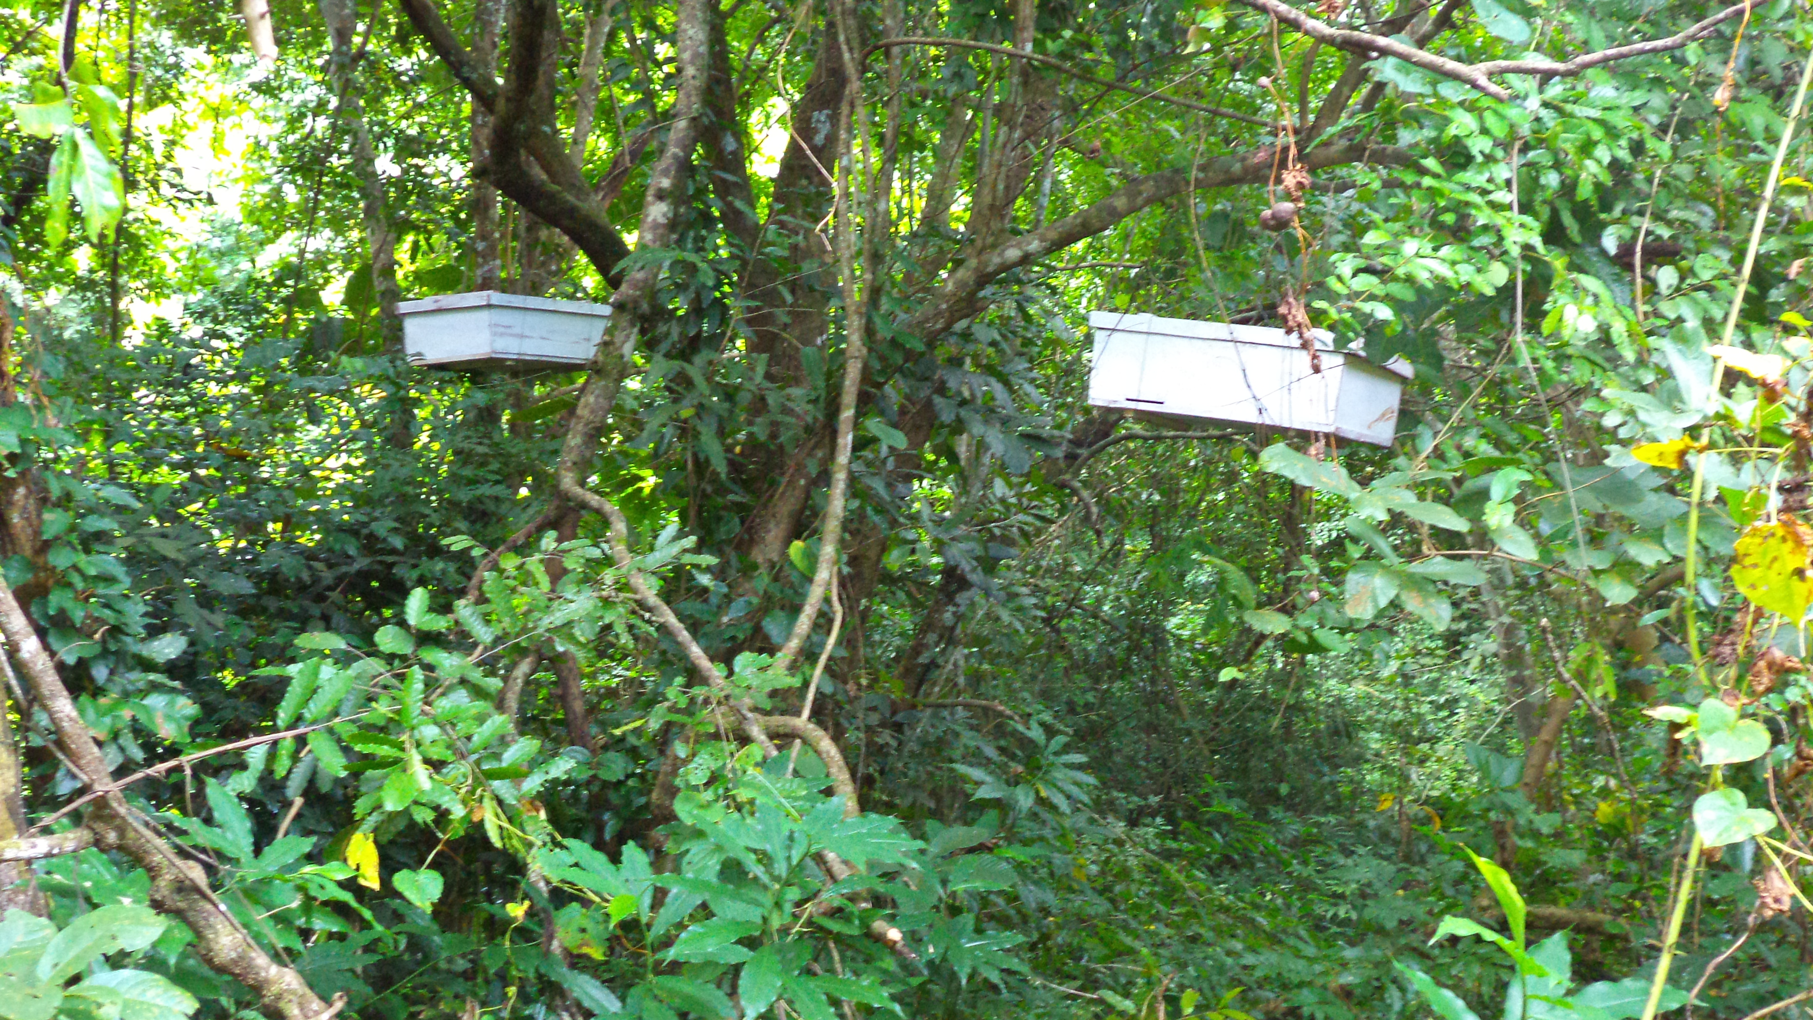
Beekeeping using Modern Beehives hanged on the tree at Mzelezi Forest Reserve in Ulanga District.
The beekeeping sector in Ulanga district is under developed due to lack of modern technology in beekeeping. This means that the potential of this sector has not fully exploited. The table below shows trend of production of honey production from 2010/11 to 2012/13. Investment in bee keeping in Ulanga district provides a special opportunity to both small and large scale investors.

Proposed investment | Beekeping
Potential target Areas  and Locations | In 7 National forest reserves (Mzelezi, Nawenge, Sali, Muhulu, Mahenge scarp, Myowe, Ligamba, Nambiga) and in 22 Villages/hamlets land forest reserves (Kamata, Isaka, Mdalangalumba, Itungulu, Chokoachokoa, Mtwangalilu, Dar es salaam, Lusulu, Chigumbagumba, Msingizi, Lipalanganga, Namadege, Igata, Namaund, Namisatu, Chemichemi, Mikeregembe, Mgambo, Miyombo, Lihongo, Mtemba and Lumbanga)

3.5 Investment Opportunities in Social Sector (Education)
The District has 22 secondary schools (Government and Private).Government Secondary schools are 18 out of which 16 being community day secondary schools and the remaining 2 are boarding schools, either Non-government secondary schools are 4, one is seminary while 3 are private schools owned by individual and religious organizations. The district (2015) has 6,314 students out of which Government schools comprises 5,098 (boys are 3,042 and girls are 2,056) and Non- government schools have 1,216 (boys are 633 and girls are 583). Government schools in the district have 396 teachers among them 305 are Arts teachers and 91 are science teachers. Government Secondary schools faces big shortage of 334 teachers’ houses 94 pit latrines, 37 laboratories and 60 science teachers.

Proposed investment | Investment in preprimary, primary and secondary schools, Vocational training institution, teacher training college, healthy training institution, up to university level.
Potential target areas | Lupiro: Is a growing commercial centre is located at two junction roads (Ifakara Mahenge road and Ifakara Malinyi road) it is located 30 km from Ifakara town and 40 km from Mahenge town. 40 ha have been earmarked for investment purposes.  Mwaya: Is a growing commercial centre located 40 km from Mahenge town. 20 ha have been earmarked for investment purposes.  Mahenge: Is a growing commercial centre located 70 km from Ifakara town and 40 Km from Lupiro town, it is the headquarter of Ulanga district, 50 ha have been earmarked for various investments.
Types of investment | Day care, Pre-primary, Primary, Secondary Schools both day or boarding schools and Technical Colleges

3.6 Opportunities in Fisheries Sector.
There are 32 different fish species, in Ulanga District, very delicious with high price in the market, the unique things in these industry is 100 % percent of community they have grown eating fish, therefore there is very strong local market, that is quick money
Fish price is going up every day, due to population increase and high dependence of captured fish. Were by their availability is in question for many reasons environmental degradation, illegal fishing, poor fishing techniques
The Ulanga Valley is an intact natural wetland ecosystem comprising myriad rivers, which make up the largest seasonally freshwater lowland floodplain in East Africa. The Ulanga River supplies ⅔ of the Rufiji waters, these give significant opportunity for fish farming, both cage culture or pond culture successfully invested in the area.
The annual harvest from Kilombero river is between (9,500 -12000 tonnes, approximately 7000 tonne per annum,(KVIEMP 2000) variety of fishing techniques is used in the area,but mostly poor fishing techniques using local traps is common, these give an opportunity for investor in fishing gear business, and transportation in the river,there is also opportunity to establish fish processing and storage facilities.
Ulanga District Council is committed to support,any investor who is willing to get quick money through fishing or fish farming.

Proposed investment | Construction of modern fishing markets and processing industries
Potential target Areas  and Locations | Lupiro Division
Rivers | Mnyera, Furua and Kilombero
Transportation/Roads | Truck Transportation from Ulanga to all major urban centres in Morogoro, Dar Es Salaam and Pwani.

3.7 Investment Opportunities in Tourism Sector

Caves
Caves found in Ulanga District were formally used by ancestors for security purposes, especially hiding themselves from enemies during the Majimaji war 1905-1907 and the First Wolrd War 1914-1918. These caves include Vigoi caves, Mbangayao caves and Kitwalo caves. Apart from using them for security purpose, they were also used as places for practicing traditional beliefs and other cultural practices by Pogoro people like Vigoi caves were used by Mloleri clan, this place found in one kilometer from district council and Kitwalo caves also were used by the Ompeshi clan, this attraction found in six kilometers from Ulanga town. Also the Mbangayao caves were used by the German people for the purpose of security. Currently these caves are used as research centre by local and foreigner students as well as good tourist attractions. Also these caves are still used as places for practicing cultural activities by local people. Although these caves are still used as places for practicing cultural activities by local people. Although these caves are very important as heritage assets still there are some problems facing them like absence of conservation and protection from the local authority and also in Kitwalo caves there is no electricity and road services passing through the caves. In these caves there are still some remains of tools which were used by Africans such as pots and the skulls of ancient people are found there. 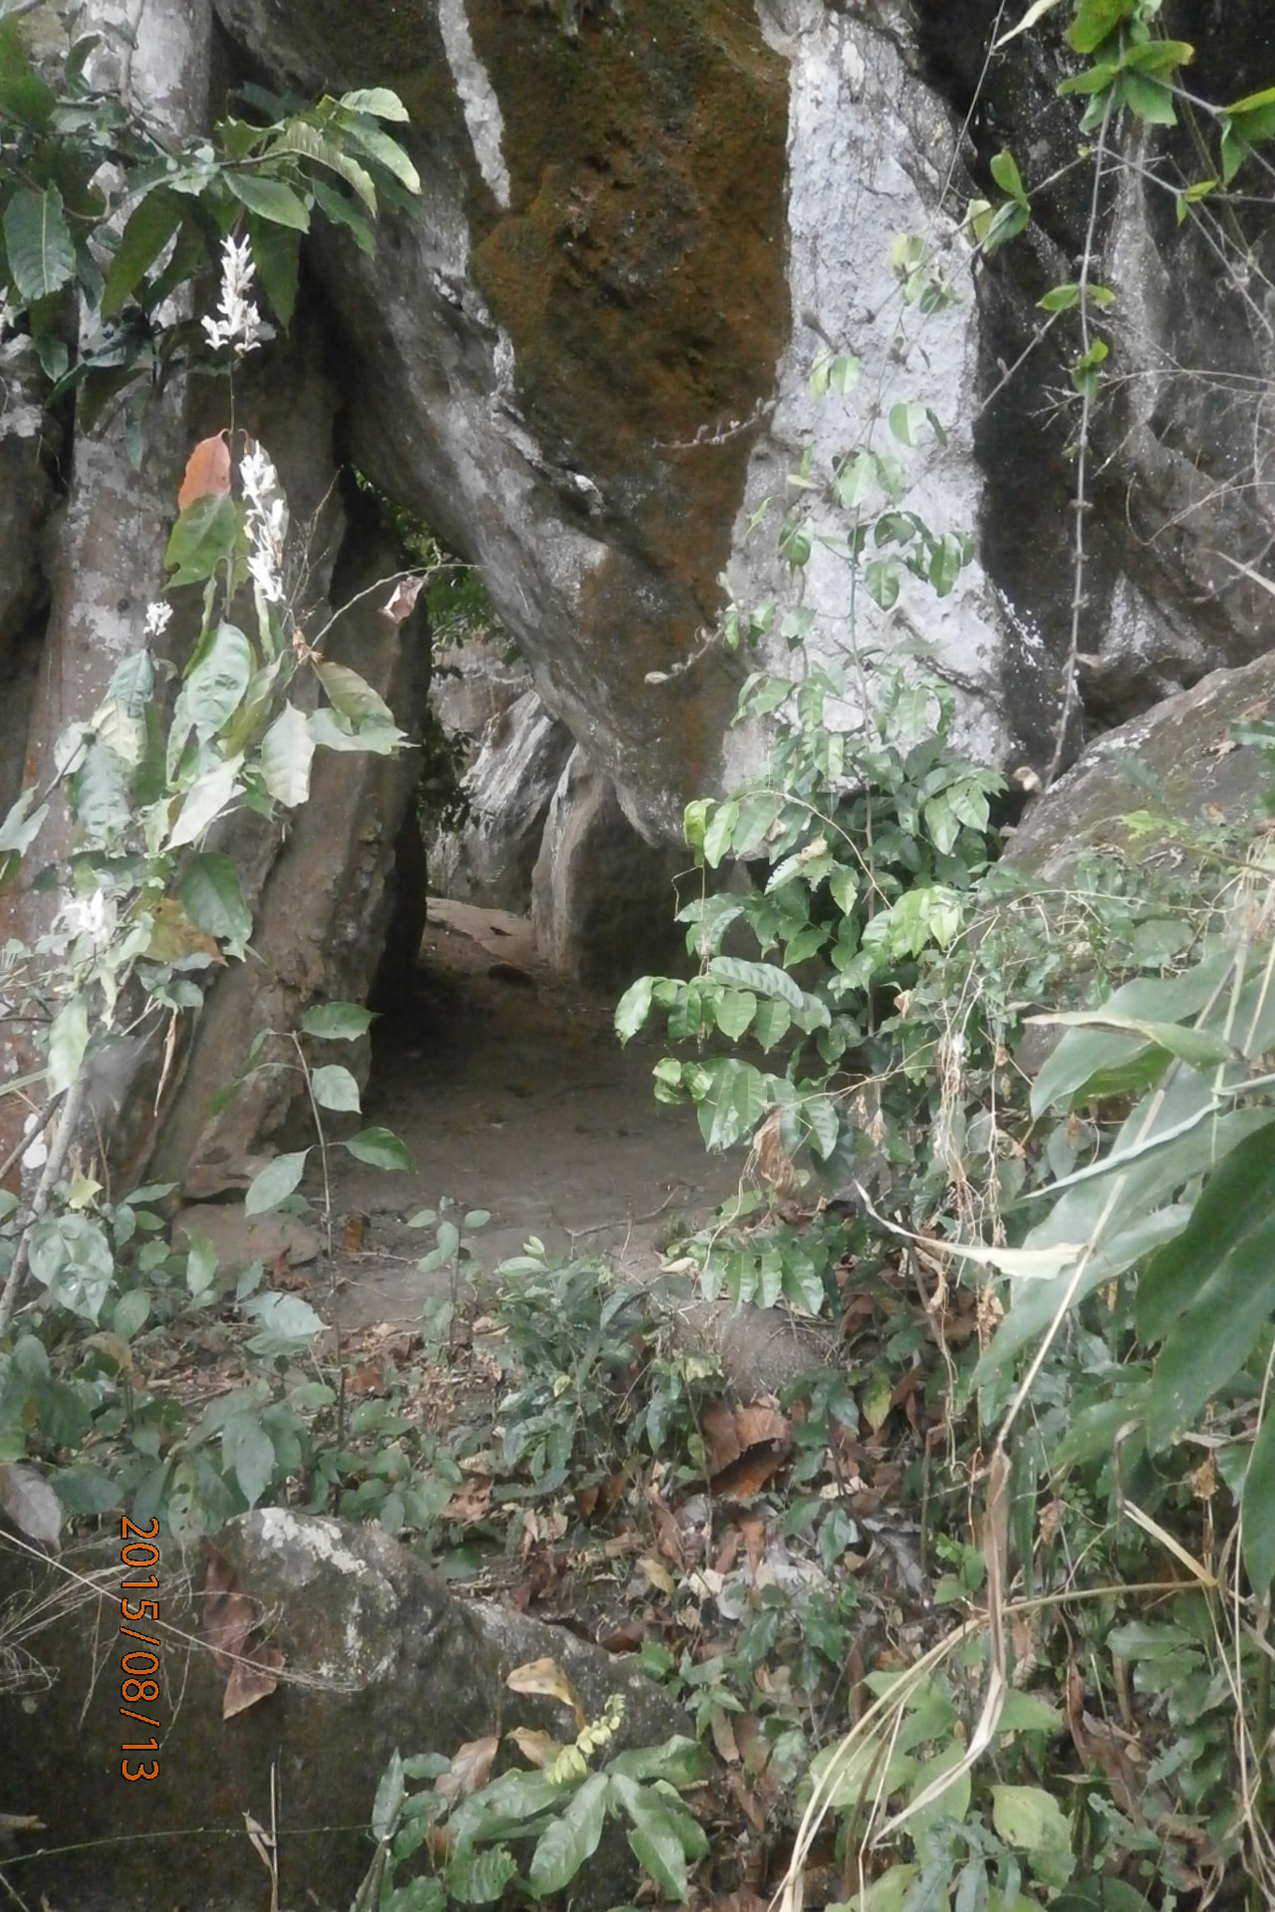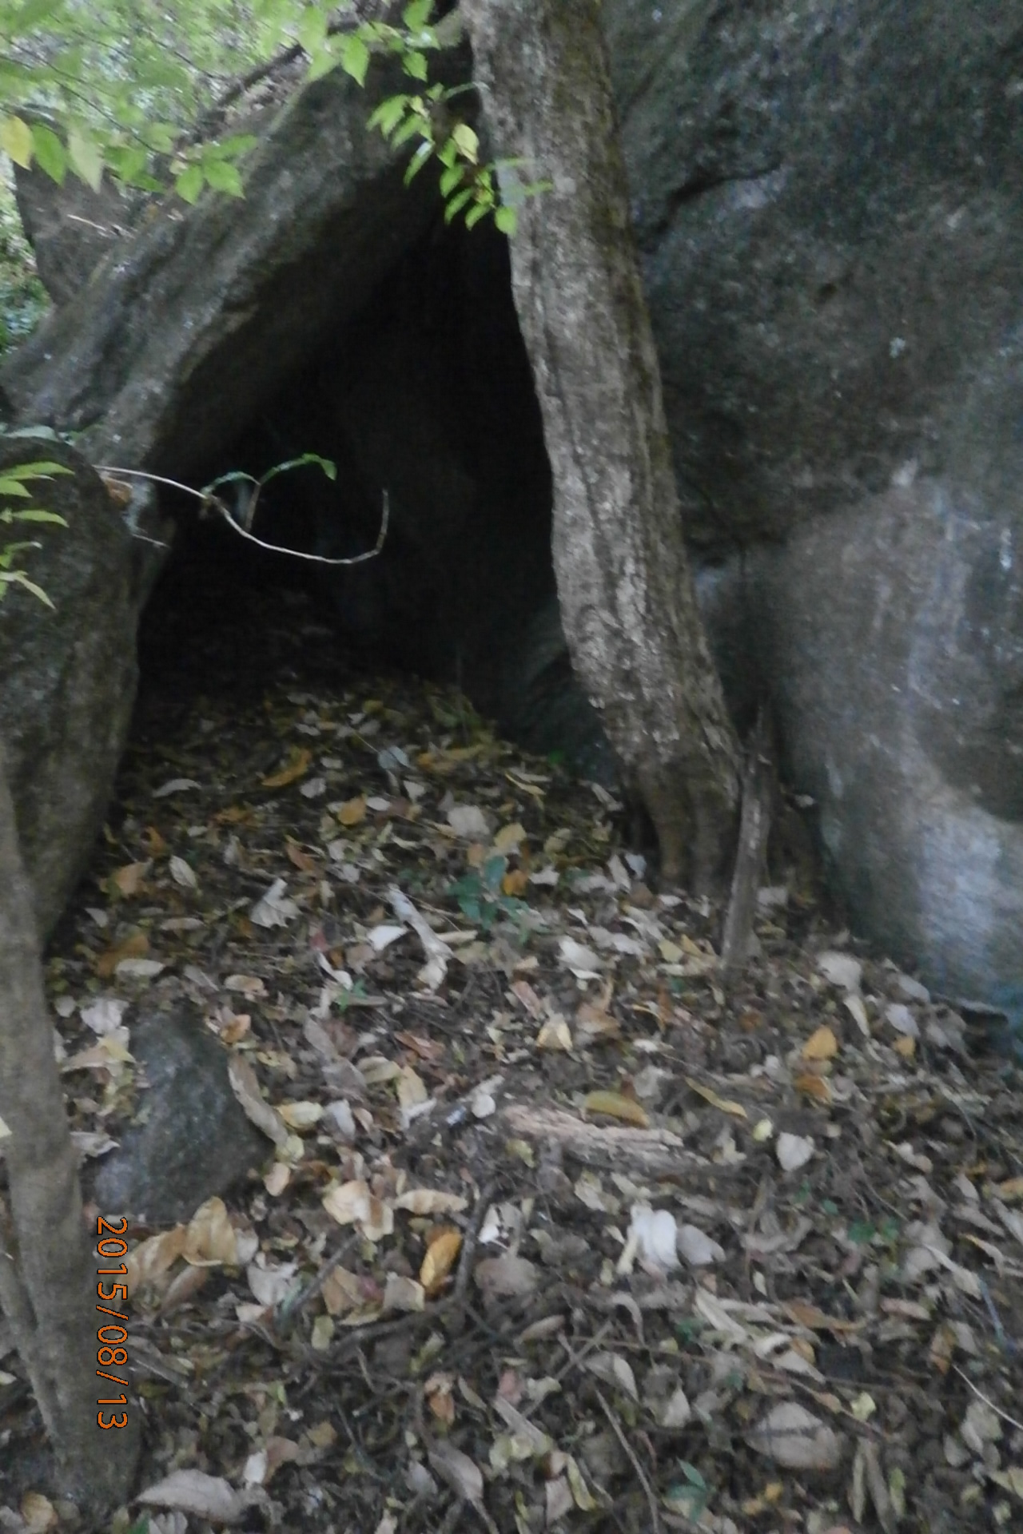

Sali Waterfalls
Sali waterfalls is found at Sali village in Ulanga District of Morogoro Region thirty(30) kilometers from the Ulanga District administrative offices. The place seemed to be very unique for natural tourism attraction in Ulanga heritage site simply because the waterfalls are very deep from the upper of the hill (mountain) and surrounded by the rocks and the forests. The area has several
social services like road, school, dispensary, church and other traditional services. There are several challenges in this place like lack of electricity and soft as well as water for drinking.
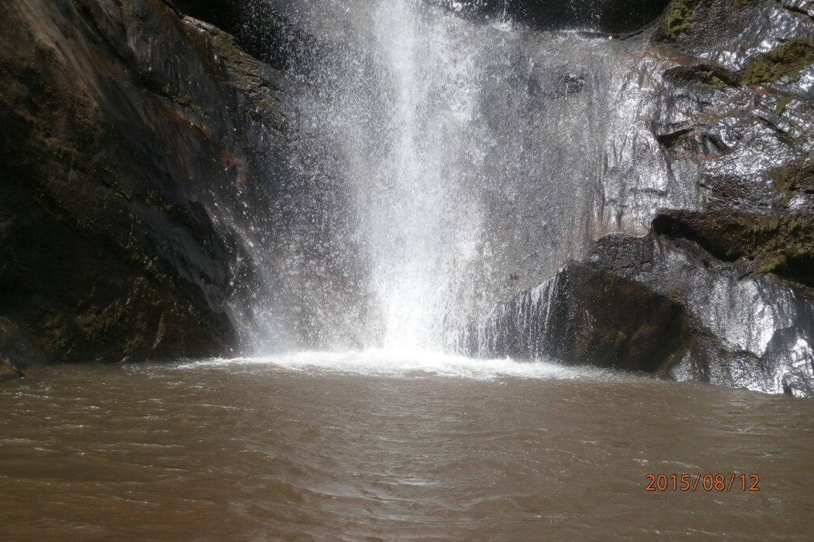
Sali Waterfalls
Generally the district is involved with a number of tourist attraction sites and there are several heritage assets to be invested. The big challenges facing the tourism sector in the district is lack of tourist’s facilities like hotels, shoppirites, campsites and other facilities needed in the field. Therefore the district attacks more investors to come and invest in tourism sector so as to boost up the sector and attack more tourists to visit our attractions.
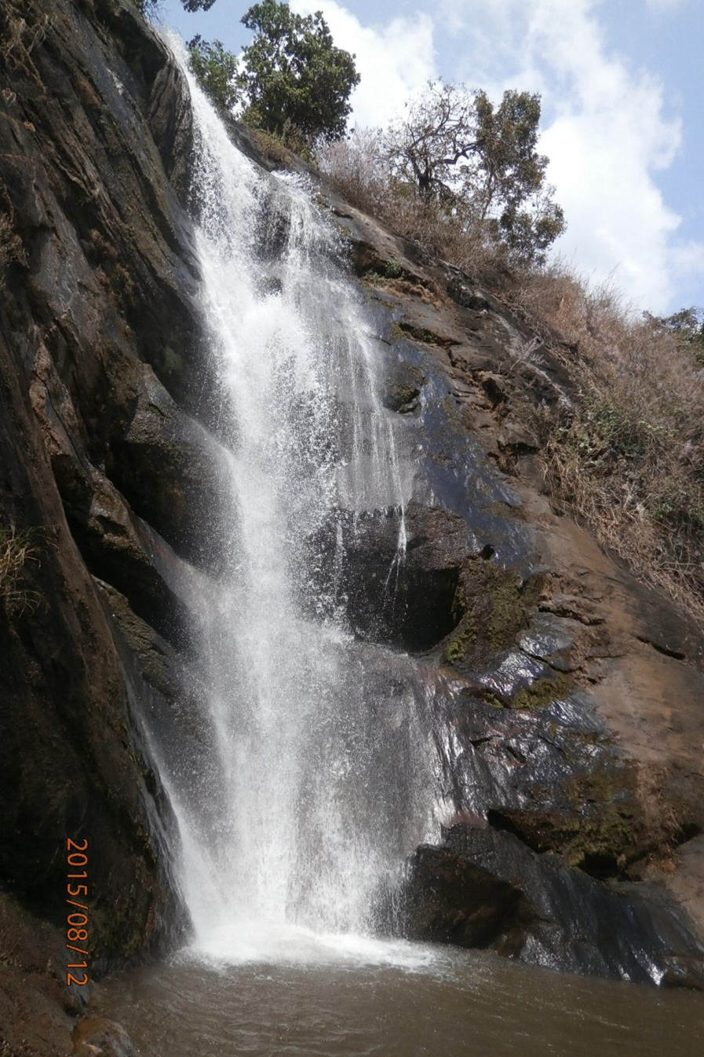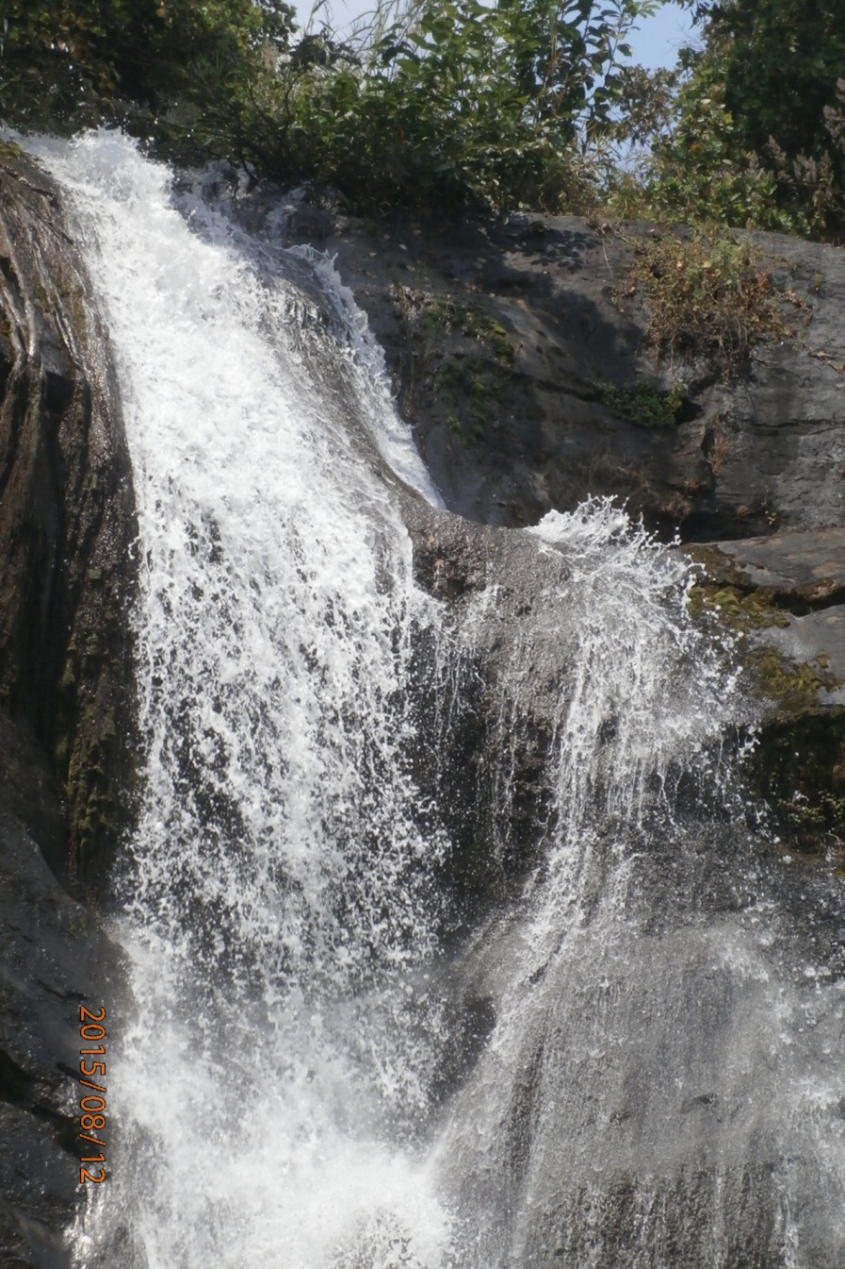
Sali Waterfalls
Proposed investment | Construction of tourists accommodation facility
Potential target Areas  and Locations | Mwaya and Mahenge urban area
Transportation/Roads | Truck Transportation from Ulanga to all major urban centres in Morogoro, Dar Es Salaam and Pwani. Air strip at Mbuga selous game reserve camp
Electricity | National grid

3.8 Opportunities in Wildlife Sector.
There are abundance wild animals in Ulanga district, investment opportunity can range between small scale wildlife ranch, hunting block for tourist hunting and photographic tourism, there are unique Puku entelope 75% in the wold are in Ulanga floodplain , wildebeest, buffalos and elephant, there are many warthog, eland and other wildlife. We have WMA Just 30KM from Ifakara,you can enjoy wildlife trip and go back to morogoro on the sameday, we have our big Kilombero Game controlled area, home for PUKU entelope,I home for wandamba tribe, these site is like Kongorongoro were Ndamba tribe fish in reserved land, with their traditional friendly culture.
Proposed investment | Wildlife business, photographic tourism, tourism hunting, game view, hiking and bird watching,
Potential Target  Areas/Locations | Kilombero valley Ramsar Site, ILUMA WMA,KILOSA MPEPO OPEN AREA.IGOTA –KETAKETA.
Type of Investors | Wildlife business

6.9 Investment Opportunities in Commercial Building
Proposed investment | Construction of commercial buildings
Potential target areas | Lupiro: Is a growing commercial centre is located at two junction roads (Ifakara Mahenge road and Ifakara Malinyi road) it is located 30 km from Ifakara town and 40 km from Mahenge town. 60 ha have been earmarked for investment purposes on processing industries and building materials (ceiling board) by using husks  Mwaya: Is a growing commercial centre located 40 km from Mahenge town. 20 ha have been earmarked for investment purposes.  Mahenge: Is a growing commercial centre located 70 km from Ifakara town and 40 Km from Lupiro town, it is the headquarter of Ulanga district. The district council has a plan of constructing business centres, thus investors are invited to collaborate with the council to achieve the planned target, and also 20 ha have been earmarked for various investments.
Types of investment | Residential houses, storage facilities, shops, buildings for banking services, conference halls, hostels, boarding schools, offices for government and non-government institutions to hire.

4.0 CONCLUSION
Ulanga offers a gifted location a reasonable workforce, plentiful natural resources and a range of opportunity for productive investment. Recent construction of Kilombero Bridge as well as upgrading of roads within the region significantly reduces transport problems, cost and time to market. Completion of Kilombero- Ngoheranga-Londo – Songea Namtumbo road it will not only join Morogoro and Ruvuma region but it will open up and widen markets of various products from Ulanga to not Songea only but to all southern regions of Tanzania in general.

YUSUF D. SEMUGURUKA
DISTRICT EXECUTIVE DIRECTOR
ULANGA DISTRICT COUNCIL

